***3.1 Rising and sinking of particles/drops/bubbles in static fluid***Particles, droplets, or bubbles in a continuous fluid will rise or sink. This provides a basis for multi-phase flow calculations.  
  
**3.1.1 Sinking velocity for solid particles**

When a particle sink with a constant velocity, the gravity force acting upon the particle has to be as large as the friction force. That gives the flow balance outlined below

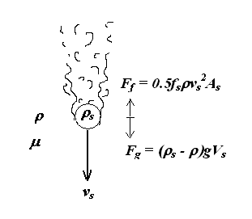

**Figure 3.1 Solid particle that falls in continuous gas or liquid**

For a spherical particle, the volume and cross-sectional area relate to particle diameter: *Vs* = *d3/6*, and *As* =* d2/4 .* By putting *Fg = Ff*, we can express sinking speed

 (3-1)

**  :density of the fluid

*s*  : Density of particle

*d*  : Diameter of the particle

*fs*  : Friction factor between the particle and the surrounding fluid

Friction factor depends on the Reynolds number of the border layer between the particle and fluid

 (3-2)

❍ : viscosity of the fluid surrounding

Figure 3.3 shows the correlation between friction factor and Reynolds number, Lydersen /1976 /. Correlation for spherical particles can also be expressed analytically

|  |  |  |
| --- | --- | --- |
| Reynolds Number | Friction Factor | Flow Ratio |
| 500 < Res < 2.105 | fs = 0.44 | Turbulent boundary layer |
| 2 < Res < 500 | fs = 18.5Res-0.6 | Transition |
| 10-5 < Res < 2 | fs = 24 Res-1 | Laminar boundary layer |

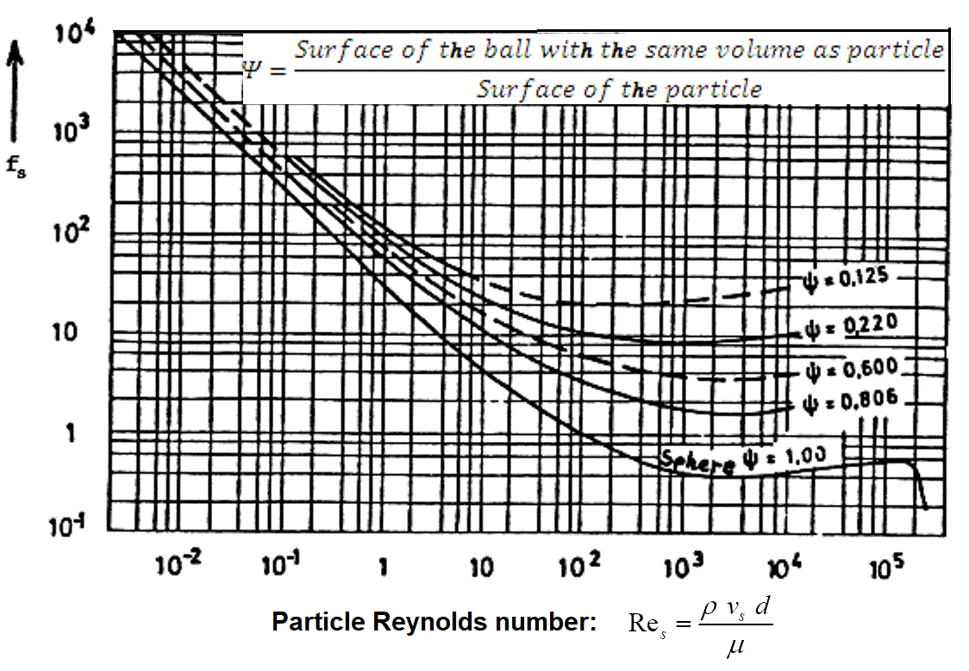

**Figure 3.2 Friction Factor for solid particles in static fluid**

If sinking velocity of sand particles is greater than the flow velocity in a vertical well, then sand will fall down and gradually fill up well. In an inclined well the falling velocity will drag particles against the lower portion of the pipe cross-section. Turbulence will help to keep the particles in dispersion. Transportation of particles further depends on whether sedimentation or dispersion dominate.   
  
  
**3.1.2 Sinking velocity of small drops**In a swarm of falling drops, the drops will continuously coalesce and break up. Turbulent forces tend to break up, while surface tension keeps drops together. This will be a continuous process, as indicated in Figure 3.3.

Consider a drop with circumference: *Sd* , the surface tension will provide a force: *F =  Sd*. The turbulent forces can be represented by the friction force, estimated by the general relationship already used above for solid particles: 

It seems reasonable to relate the maximum drop size to the ratio of these forces. This provides the critical Weber number. For a spherical drop, this can be expressed as

 (3-3)

σ: Surface tension (N / m)   
*vs\** : sinking velocity of the largest drops

Experiments indicate largest achievable (critical) Weber number in the range of 20-30. By setting (3-3) in relation with sinking velocity (3-1), we can express maximum sinking velocity as

 (3-4)

*K*  : dimensionless parameter group: 

For droplets sinking in static gas, the parameter group has been experimentally determined, in the range: *K=Kd = 2.75-3.1*

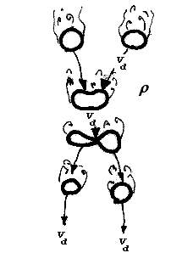

**Figure 3.3 Drop size in continuous gas**

The majority of gas wells also produce some liquid, water and / or condensate. Velocity of small droplets may be used as a criterion for flow velocity to prevent fluid accumulation in the well, Turner & al / 1963 /. The idea is that although liquid largely is found as a film along the pipe wall, it is mainly be lifted as droplets. If the gas velocity is greater than sinking velocity for the largest liquid drops, they will be transported out.   
 **3.1.3 Rise velocity for small bubbles**   
Small bubbles that rise in the continuous liquid are subjected to similar forces as liquid droplets in the gas. Stability consideration and the formula for maximum velocity for the rising gas bubbles are similar. Thus, the rise velocity relationship should be equal to (3-4) above, with different proportionality constant, since flow conditions around a gas bubble that rises in viscous liquid will be different from a liquid drop that falls in small viscous gas

 (3-5)

.For gas bubbles the rise in the stagnant liquid Harmathy /1960 / found: Kb = 1.53.   
  
  
**3.1.4 Rising velocity for big bubbles**

If bubbles are so large that they fill the entire cross-section of the pipe, (figure 3.4), they will be stabilized by the pipe wall. Rise of large air bubbles in the water is primarily governed by liquid flow around the bubble front. After passing the bubble front, the liquid will flow along the pipe wall as a free-falling film, which has no influence on the rise velocity. Rise velocity has been derived theoretically by Dumitrescu / 1943, . Dimension Analysis and measurements of Davis & Taylor / 1950 / gave nearly identical results.

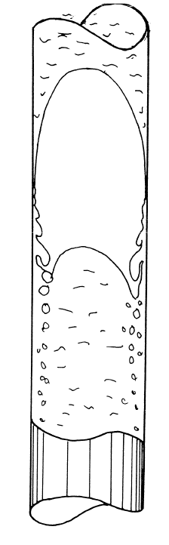

**Figure 3.4 Large bubble in the pipe (“Dumitescu /Taylor bubble")**

 (3-6)

*vD*: rise velocity of large bubbles in the vertical pipe   
D : inner diameter of pipe

The sinking liquid film will mix with gas bubbles in boom, as illustrated above. By comparing (3-5) and (3-6), we find that small air bubbles rise faster than the large ones if pipe diameters are less than 50 mm. This means that the small bubbles in the small pipe will have the tendency to collide and coalesce with large bubbles. While in large pipes, small bubbles that separate from the end of a larger one will trail behind. Based on this, it has been argued that Dumistrecsu bubbles are not stable when the pipe diameter is greater than 50 millimeters.

Zukoski / 1966 / explored the rising velocity of the large bubbles for different surface tensions, viscosity and pipe inclinations. Surface tension appeared to have some effect on small pipe diameters. The effect of viscosity attributed to the Reynolds Number defined by fluid density, liquid viscosity and the rising viscosity of the bubble: *Re =  vD D/.* Viscosity had little significance for Reynolds Number above 20. Zukoski found that the bubble velosity reach a maximum at pipe slope around 35o compare to the horizon (inclination 55o)  
  
Rise velocity for large oil accumulations in inclined pipe filled with water has been experimentally found to be in reasonable compliance with Zukoski’s results. In the vertical well, oil was found to disperse.   
  
  
**3.1.5 Bubbles and droplets of flowing fluid**   
Turbulence forces due to flow will also break up drops and bubbles. Hinze / 1955 / considered the relationship between the turbulent forces and surface forces as a Weber Number.

 (3-7)

Break up forces are due turbulent velocity fluctuation:  This can be relatioed to energy dissipation

 (3-8)

Energy dissipation may have different causes: the flow through nozzle, mechanical stirring, wall friction, pumping. For flow in the pipe energy dissipation per mass unit relates to friction loss

 (3-9)

By putting (3-8), (3-3) into the relationship between the turbulent forces and surface forces into the Weber number (3-7), we can associate the maximum droplet size to the fluid in flow conditions

 (3-10)

The dimensionless constant relates to the critical Weber number of (3-7): . Experimentally the constant has been determined as

*C =0.725*.

By combining the relationships above, it is possible to predict how the sinking velocity of a drop (or rise of bubbles) will depend on the flow speed. Figure 3.5 shows the prediction for parameters:* g = 15 kg/m3, l = 1000 kg/m3, f =0.02,  = 60 .10-3 N/m, D = 0.1 m, Kd=3.1.*

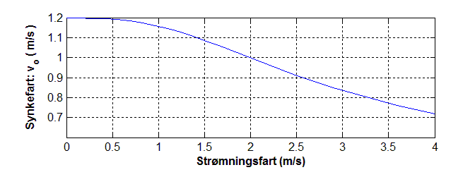

**Figure 3.5 Sinking velocity for droplets in flowing gas**  
The figure shows that when the velocity is less than 0.2 m / s, the bubble size in the flowing liquid larger than the size of the bubble in the stagnant fluid. Thus, it may be expected that the size is controlled by turbulence in the boundary layer due the bubble rise. So a maximum bubble size of about 27 millimeter may be expected. At higher velocity, the turbulence generated by the overall flow will control the bubble size. So the maximum bubble size will decrease with rising flow velocity. (To estimate the drop size more realistically, we should to "add" turbulence contributions from buoyancy and flow.)   
  
The relations above may also be useful for separator design. Well and valves ahead of the separator should be arranged and dimensioned so that high turbulence and fine dispersion are avoided .

***3.5 References***  
1943 Dumitrescu, DT: "Strömung an einer Luftblase in senkrecthen Rohr"   
    Z. angew. Math. Mech., 1343, vol. 23, no. 3, pp 133-143   
  
1950 Davis, R.M., Taylor, G.I.:   
"The Mechanics of Large Bubbles Rising Trough   
Extended Liquids and Through Liquids in tubes "   
Proc. Royal Soc., London, vol. 200 series A, 1350, pp 375-330.   
  
1955 Hinze, J.O.:   
"Fundamentals of the Hydro Dynamic Mechanisms of   
Splitting in Dispersion Processes ",   
AICHE J. (Vol 1, No. 3), 1335, pp 283-235   
  
1960 Harmathy, T.Z.:   
"Velocity of Large Drops and Bubbles in Media   
Of Infinite or Restricted Extend "   
AICHE, no. 6, p. 281, 1360. 

1966 Zukoski, EE: "Influence of viscosity, surface tension and inclination   
Wednesday angle motion of long bubbles in closed tubes "   
Journet. of Fluid Mechanics 1336, vol. 25, p. 4, pp 821-837. 

1977 Kubi, J., Gardner, GC: "Drop sizes and Drop Dispersion in   
    Straight Horizontal tubes and Helical Coil "   
Chem.Engr.Sci., Vol 32, 1377, pp 135-202.   
  
1978 Karabelas, A.J. "Droplets Size Spectra Generated in turbulent Pipe   
Flow-Dilute of Liquid / Liquid Dispersions "   
AICHE Journal, Vol 24, No. 2, March 1378, p 170 